South Ribble Borough Council
Mobile Homes Fees Policy
2017/18

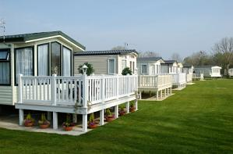
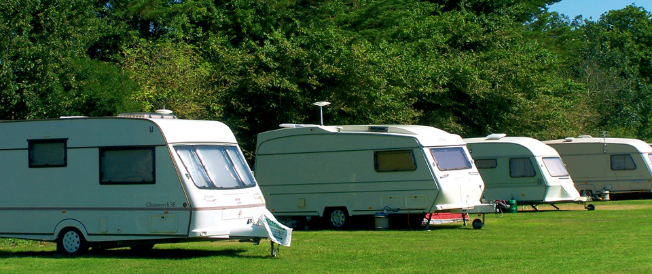

Contents
- Introduction
- Fees charged for licensing
- Application for a new site licence
- Transfer/Amendment of an existing site licence
- Annual fees for site licences
- Enforcement Costs
- Fees for depositing Site rules
- Publishing and revising the fees policy

Appendix 1 – Elements which can be included in fee setting
Appendix 2 – List of current Mobile Home Sites with South Ribble

Related documents
The following documents have been consulted when drafting this policy:
- The Caravan Sites and Control of Development Act 1960 as amended (CSCDA60)
- Mobile Homes Act 2013 (MHA 2013)
- Regulators Compliance Code
- RBC Corporate Enforcement Policy
- DCLG Guidance on Site Licensing Fee Setting
- https://www.gov.uk/government/uploads/system/uploads/attachment_data/file/285926/140227__ A_guide_for_Local_Authorities_on_setting_site_licensing_fees.pdf

Introduction
South Ribble Borough Council has granted Caravan site licences under The Caravan Sites and Control of Development Act 1960 (as amended) (CSCDA60) for sites that have planning permission for a caravan site.
The CSCDA60 has now been amended by the Mobile Homes Act 2013 (MHA 2013). The MHA 2013 was introduced in order to provide greater protection to occupiers of residential park homes and caravans as the existing legislation had not been updated for more than 50 years.
This Act introduces some important changes to the buying, selling or gifting of a park home and the pitch fee review process. There is an expectation that councils will inspect sites annually and use the additional powers to ensure compliance with site licence conditions.
The council can also now charge a fee for different licensing functions, serve enforcement notices and publish any site rules relating to a site. The Fee generated by the MHA 2013 is not designed to include investigation of harassment or matters not related to the Site Licence – these should be dealt with through Residents Associations or other appropriate channels.

Fees charged for site licences
The changes introduced by the MHA 2013 for Site Licensing came into force on 1st April 2014.
These include powers for local authorities to charge fees for their licensing functions in respect of “relevant protected sites”. A relevant protected site is defined in the Act as any land to be used as a caravan site with planning consent, other than one where a licence is:
- Granted for holiday use only
- In any other way subject to conditions which restrict the usage of the site for the stationing of caravans for human habitation at certain times of the year (such as planning conditions).
Relevant protected sites to which the legislation applies are typically known as residential parks, mobile home parks and Gypsy Roma and Traveller sites and so on.
Sites which do not fall within the definition of ‘relevant protected sites’ are still subject to the licensing requirements contained within the CSCDA60, but the provisions relating to payment of fees do not apply.
Under the new Act, a fee can be charged for:
- applications to GRANT a new licence
- applications to TRANSFER or AMEND an existing licence
- Annual licence fees for administering and monitoring existing site licences.
This policy details the fees to be charged for all of these licensing functions.
The fee levels have been calculated based on the estimated average time and costs involved in undertaking the activities involved. (Appendix 1 details what the council can consider in calculating the fee levels)
The fee rates set out in this policy cover the period from adoption until 31st March 2019.

Application for a new site licence
All sites require a site licence to operate (subject to exemptions in the CSCDA60); failure to apply for licence is an offence under Section 1(2) of CSCDA60.
The council may only issue a licence for a site with a valid and correct planning permission for the use.
Any application made before the planning status has been awarded must be processed within 6 weeks of the planning decision.
Sites which already have the correct planning permission in place must be processed within 2 months of the licence application.
The fee for a new site licence is currently £260.57 fixed cost plus £6.50 per pitch to reflect the variation in the cost of processing the application according to the size of the site.

Transfer / amendment of existing site licence
Where a licence holder wishes to transfer the licence an application must be made to the council, for which a fee is payable. The fee must accompany the application to transfer the licence.
Similarly where a site owner requests an amendment to site licence conditions, the council can charge a fee for this function.
Applications can be made by licence holders to vary or cancel conditions; the fee is payable at the application stage.
If the council deem it necessary to alter conditions, there will be no fee payable.
The fee for an application for transfer or amendment of up to two site licence conditions is currently £104.90.
Where significant amendments to the site licence conditions are requested this is likely to involve a site visit so the fee for this licensing activity will increase to £181.65.

Annual fees for Existing Site Licences
All relevant protected sites must pay an annual fee to the council (subject to any exemptions stated in this policy). The fee is due on 1st April each year and annually thereafter.
The annual fee covers the costs associated with administration, an annual site inspection to ensure compliance with the site licence conditions and a revisit to ensure compliance with any outstanding works required. If there is still a breach in site licence condition at the point of the revisit further charges may be payable to cover the cost of any enforcement action which may be taken.
(See Enforcement costs – section 6)
The fee is currently £7.97 per pitch and is calculated on a price per unit based on the total estimated cost to the council of carrying out its annual licensing function for all sites in the Borough. The unit cost is multiplied by the actual number of units on each site to provide the annual fee payable.
The DCLG guidance for fee setting offers a variety of suggested options for local authorities in calculating the annual fee:
- Option 1 – fee per pitch (A fee based on the total cost to the local authority carrying out its annual licensing function for all sites, divided by the total number of units over all the sites which will give a price per unit)
- Option 2 – fee based on site size bandings
- Option 3 – fee based on a risk rating that takes into account the size of a site; the level of compliance on a site and confidence in management
Option 1 has been adopted as it is considered to offer the most transparency and fairness to both residents and site owners.
Initial charges have been based on average estimates. Fees will be assessed each year to determine accuracy as part of the Council’s annual fees and charges setting process.

Conditions
The conditions on the existing site licence will remain the same until the Council deem they are out-dated or incorrect and then a review will take place or unless an application is made to amend conditions on the licence by the site owner.

Sites exempted from Annual Licensing fees
- Sites that are not relevant protected sites
- Sites with 3 units or less
- Sites for the Site owner and their family (does not include sites that are run for financial gain)
These categories of site are exempt from the annual licensing fee as the council do not intend to carry out annual inspections of these sites, however, any complaints would be dealt with as appropriate.

Charging Arrangements
For the purpose of this policy the period covered by the annual fee will be 1st April to 31st March each financial year.
The fee will be charged to the site owner / licence holder and invoices will be sent at the start of the financial year with payment due within 30 days. (Legislation allows the licence holder to pass on the annual fee cost to the resident’s pitch fee)
Where a new site licence is issued part way through the year, the annual fee will also be due in the same year and an invoice will be sent after the licence has been granted for the pro-rata amount.
Where an amended licence is issued part way through the year (which included either additional units or a reduction in units), the change in annual fee would be calculated on a pro-rata basis for the remainder of the year and difference in fee would be adjusted against the following years annual fee.
In the event an annual fee is not paid within the terms of the invoice, the council may apply to the First Tier Tribunal (Property Chamber) for an order requiring the licence holder to pay the amount due.

Enforcement costs
Where there has been a breach in a site licence condition which comes to the attention of the council we may serve a compliance notice.
The CSCDA60 details the elements which a local authority may include when imposing a charge for enforcement action. These include the time involved in deciding to serve and prepare the notice. A detailed breakdown of the relevant expenses would be provided with the compliance notice. Charges would be based on an hourly rate in addition to any other costs incurred for example legal costs.

Hourly rate for enforcement costs = £33.38
Charges for enforcement costs cannot be passed onto the residents pitch fee.
If any works in the compliance notice are not carried out, the licence holder commits an offence and the local authority may consider taking legal proceedings. Any costs associated with this process would be at the discretion of the court.
If a prosecution was successfully taken, the council would have the power to carry out the works in default of the licence holder.

Fees for depositing Site Rules
Site Rules are different to the site licence conditions and are put in place by the owner of a site to ensure acceptable standards are maintained, which will be of benefit to occupiers or will promote and maintain community cohesion on the site.
The MHA13 changes the way site rules must be agreed between both parties. The council must keep an up to date register of site rules on relevant protected sites and publish the register on-line.
Before publishing the site rules the council will ensure the rules deposited have been made in accordance with the statutory procedure – a fee can be charged for this function.
Any site rules deposited with the local authority for the first time or applications to vary or delete existing site rules must be accompanied by the appropriate fee.
The fee is the same for either a first deposit or for a subsequent variation or deletion. This is because the process will be very similar for all three types of deposits.
The fee is currently £81.14 and reflects the fixed costs for this function.

Publishing and revising the fee policy
This fees policy will be published on the South Ribble Borough Council website at: www.southribble.gov.uk.

The fees detailed in this policy have been determined based on experience of dealing with site licensing historically with consideration of the changes the new Act has introduced.
Some of the processes are new (for example the depositing of site rules) and therefore estimates have been made as to the cost of providing these services. In addition, at the time of producing this policy some elements of the licensing regime are still awaiting further regulation by government which may impact on the processes and the time involved and may therefore result in a revision to the proposed charges.

This policy will be revised no later than 31 March 2019.

APPENDIX

Appendix 1 - Elements included in fee setting
The DCLG guidance sets out the activities that the council can include when calculating its annual fee, these include:
- letter writing/ telephone calls etc. to make appointments and requesting any documents or other information from the site owner or from any third party in connection with the licensing process;
- handling enquiries and complaints;
- updating hard files/ computer systems;
- updating the EU Directive website if appropriate;
- processing the licensing fee;
- time for reviewing necessary documents and certificates;
- downloading photographs;
- preparing reports on contraventions;
- review by manager or lawyers
- review any consultation responses from third parties;
- carrying out any risk assessment process considered necessary
- A pre- programmed full site inspection;
- A follow – up inspection to check compliance following programmed inspection

APPENDIX 2 – List of current Mobile Home Sites with South Ribble
- Carrwood Park, Oakland Glen, Walton-le-Dale PR5 (80 plots)
- Croft Park, Wigan Road, Leyland PR25 (Approx. 50 plots)
- Penwortham Residential Park, Off Stricklands Lane, Penwortham PR1 (78 plots)

TOTAL – 208 plots

